March 22, 2023—Java Project – Thea Gregory 5291240

Today I worked on the following:

* Completed the view for create restaurant
* Completed the model and validation functions for create restaurant
* Began work on the controller for create restaurant

While it felt like I didn’t accomplish much, assembling the interface for this portion took quite a while. I needed to make sure all necessary fields were included, as they were not all present on the sample and I found them by re-reading the use case. I am pleased with how I handled the validation for the opening hours comboboxes, I found my solution to be simple yet effective. Not much has yet been done on the controller. The interface has many buttons, but three of them can be implemented from other completed queries in my DBManager class so it probably looks worse than it is. Code re-use is key here. In general, I feel that my progress was good and that I have a solid handle on what I need to complete this part of the task.

Screenshots:

Part 1 of view:

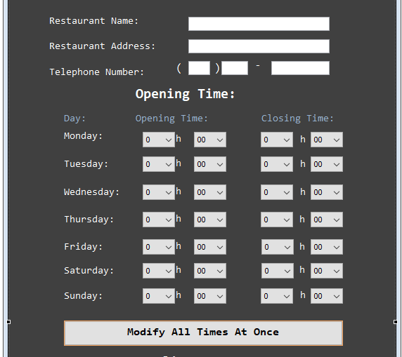

Part 2 of view:

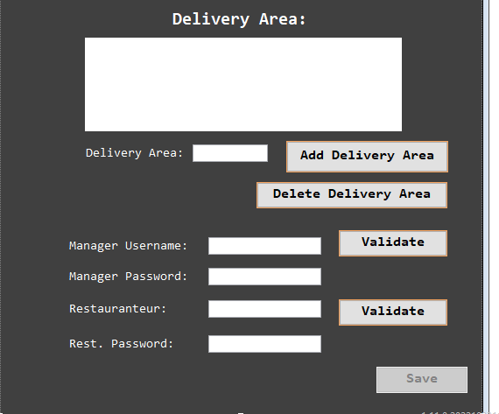

Validation logic for opening hours: (I used 24 hour time in the combobox to simplify computations.)

